# Value Iteration - 5x5 Gridworld

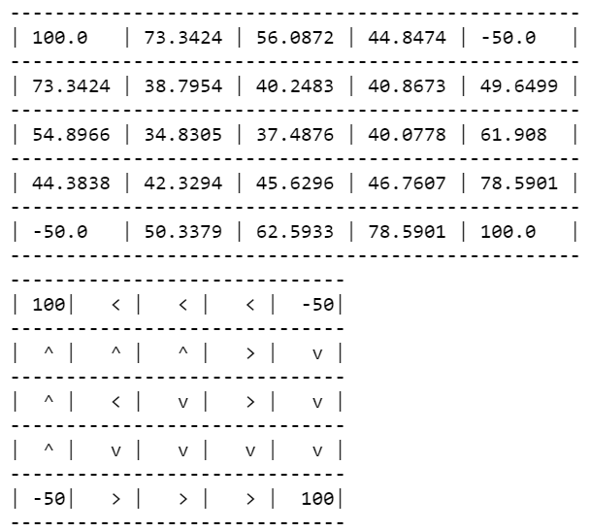

32 iterations

# Q-learning - 5x5 Gridworld

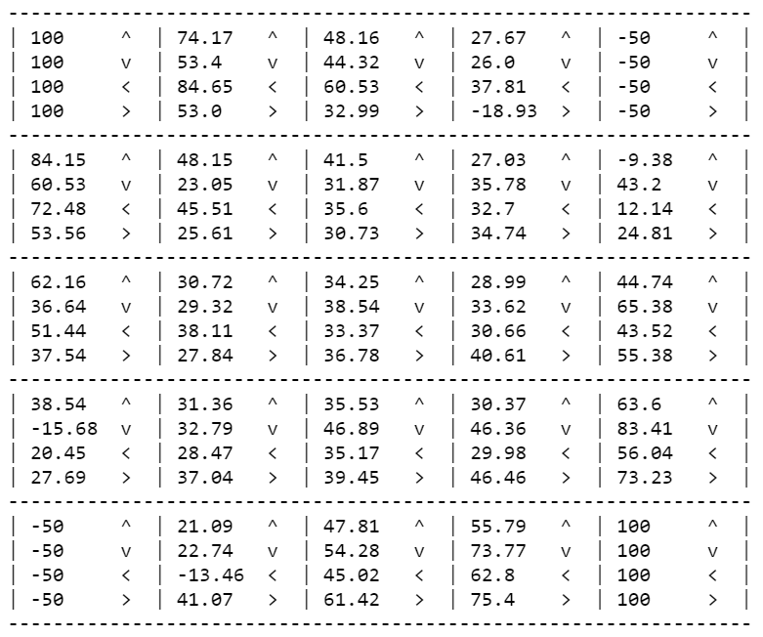

10000 iterations

